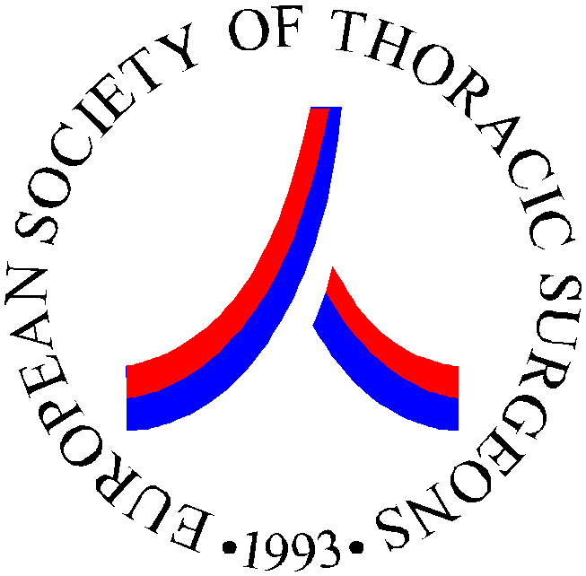APPLICATION FOR MEMBERSHIP
Closing Date for Applications 31 March

Please complete and return to the address below.

FAMILY NAME TITLE

FIRST NAME Date Birth

Male  Female 

HOSPITAL ADDRESS:

HOSPITAL/DEPT.

STREET

CITY COUNTRY POSTCODE

TELEPHONE FAX

HOME ADDRESS:

STREET

CITY COUNTRY POSTCODE

TELEPHONE FAX

EMAIL (Most Important)

- Please send my Journal to my Hospital Address
- Please send my Journal to my Home Address
- I do not wish to be included in the Society mailing list for conference announcements and thoracic industry meetings

SPONSORS – CURRENT FULL MEMBERS OF ESTS
We, the undersigned, recommend this applicant for

- Active Membership
Surgeons predominantly practising thoracic surgery

- Trainee Membership
Surgeons in training positions in thoracic surgery- maximum age 35 years

1.NAME__________________________SIGNATURE_________________

2.NAME__________________________SIGNATURE_________________

I hereby apply to be admitted to the European Society of Thoracic Surgeons as:

Year 2013

◻ Active Member € 230
(high income countries)
All countries not listed below

◻ Active Member
(high middle income countries) € 150
Belarus, Bosnia and Herzegovina, Bulgaria, Kazakhstan, Latvia Lithuania, Macedonia FYR, Montenegro, Romania, Russian Federation, Serbia, Turkey, Turkmenistan

◻ Active Member
(low middle income countries) € 50
Albania, Armenia, Georgia, Kosovo, Moldova, Ukraine

◻ Trainee Member € 50
◻ Existing Junior EACTS Member € 50
◻ Existing members of EACTS € 115
◻ Existing members of STS from 2010 € 200
◻ Dual Membership ERS Members € 200
(pulmonologists)

Full membership: accredited surgeons qualified as specialist and predominantly (ie >50%) practising the field of general thoracic surgery.
Members of EACTS qualify for a reduction as they will not receive the European Journal from ESTS.
Trainee membership: surgeons in training positions in thoracic surgery
(maximum age 35 years)
Please include a letter from the Head of your Department confirming you are a trainee

Please include a brief CV in English including your operative practice and publications. The Membership Committee will review your application and you will then be invited to pay your membership fee.

